**Slides**

**Lecture = 10**

**Management Accounting**

*After reading this chapter, you should, in simple cases:*

* *be able to calculate the cost of labour;*
* *understand the concept of overheads and the different ways in which they may be distributed;*
* *be able to determine how much it costs to produce a particular product or provide a specific service;*
* *understand how to produce a budget and a cash flow forecast, and how to monitor them*

**COST OF LABOUR**

* The cost of employing someone is more than just the cost of their salary. In most countries, employers are required to pay a tax for every employee. This tax usually goes by a name such as *employers’ national insurance contribution* (in the UK) or *social security contribution; it is proportional to the* employee’s salary. In some countries, this contribution may be as large as 60 per cent of salary, while in others it is very much smaller.

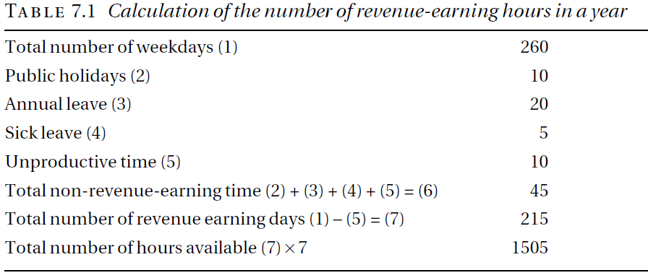

**Pay roll**

The total cost of employing a person, that is, the salary plus employers’ social security contributions plus any other costs associated directly with the employee, is sometimes known as the employee’s *payroll cost or direct cost.*

***Example :***

* *Consider a technician who is employed* to assemble the computers and suppose that he is paid an annual salary of £20,000. His payroll costs are £22,000.
* The direct cost of the technician is £22,000 per year so that the direct cost of an hour of their time is £22000/1505 = £14.62**.**

**OVERHEADS**

* Costs that cannot be directly associated with a particular product are known as overheads.



**BUDGETING**

* A budget is a financial plan showing the expected income and expenditure for an organization over a specific period, typically one year.

**Example**

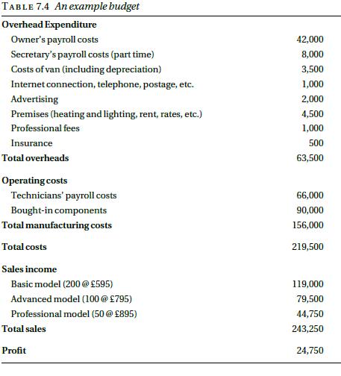

**CASH FLOW FORECAST**

A company may be very profitable but unable to pay its bills. For that reason, it may be forced into receivership. This apparent paradox typically arises because bills have to be met, in particular staff have to be paid, before the income they generate is received. In order to avoid this difficulty businesses need to prepare cash flow forecasts, that is, estimates of the amount of money that will flow into and out of the company each month.

**Lecture = 11**

**Investment Appraisal**

Less resources and more number of proposals lead company owners and investors to decide which proposal to drop which to pick.

Investment appraisal is a process that evaluates the costs and benefits of an investment to determine its suitability. It involves analyzing the profitability of an investment over the life of an asset, as well as its affordability and strategic fit

**Investing in…..**

There is no single way of assessing and comparing the different proposals;

factors that must be taken into consideration include, for example:

* the extent to which the proposals are consistent with the company’s
* long-term plans;
* the risk attached to the proposals;
* the availability of the necessary resources even if the money is available.

**DCF(Discounted cash flow)**

One important criterion, however, is the financial one: which of the proposals

will give the best return on the investment? The usual way of determining

this is to use the method known as discounted cash flow (DCF)

It is important to realize that DCF is a tool that is used for many different

purposes, for example:

* by investors on the stock market to assess whether the share price of a company reflects accurately its financial prospects;
* to assess whether it is better to purchase capital equipment or to lease it;
* to decide which of several possible projects is the most financially appealing;
* to decide whether a proposed capital project will be worthwhile.

**THE TIME VALUE OF MONEY**

Money available at present time is worth more than the same amount in the future due to its potential earning capacity.

**Purchasing vs leasing**

Suppose you want to get a car worth Rs.10,00,000/- and you have that amount.

The car finance department offers you to lease the car providing you pay a down payment of 20% that is Rs.2,00,000/- and a monthly payment of Rs.20,000 for 5 years(60 months).

Thus,

(20,000 * 60) + 2,00,000 = 14,00,000

While if you purchase it you have to pay Rs. 10,00,000/-

Would you purchase the car or lease it on these terms?

**Interest rate**

Suppose you put your Rs.10,00,000/- in the bank provided the bank gives you an interest of 10% per annum

Thus

(10/100) * 10,00,000 = 100,000 per annum

Discount factor

In general, if the interest rate is r (expressed as a fraction such as 0.08, not a percentage), then the present value of a sum of money X due in t years time is:

X ÷ (1 + *r*)*t*

*Or,*

The quantity 1 ÷ (1 + *r*)*t* is known as the *discount factor*.

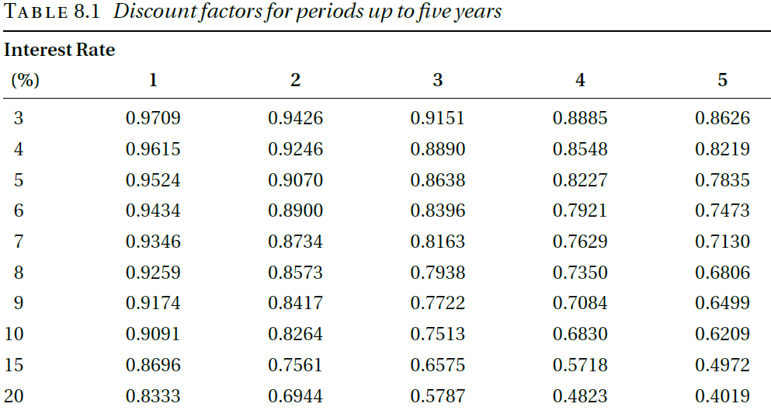

**Example**

A new van will cost £10,000. There will be annual costs of £500 for insurance and £150 for road tax. The cost of maintenance is estimated to be £200 in each of the first two years, £300 in year 3, £400 in year 4 and £500 in year 5.

At the end of the fifth year, it is expected that the van will be sold for around £2,000. The interest rate that the company pays on its borrowings is 10 percent.

**If the van is hired(rented)**

Van hire costs £35 per day and it hires a van for about 100 days a year. All the costs are subject to inflation, which is judged to be around 5 per cent over the period, but the resale value of the van is the cash figure expected at the time.

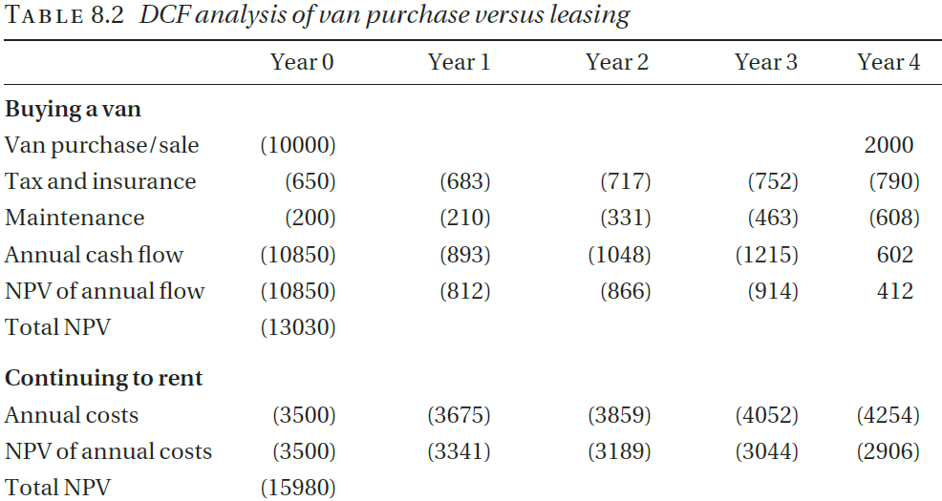

**Cost of capital**

* This means that even if the company can buy the van outright, it incurs an "opportunity cost" by not investing that cash elsewhere, where it could earn interest. In the discounted cash flow (DCF) analysis, this lost interest is effectively the cost of using cash to buy the van, so it’s used as the discount rate.
* Suppose a company has £10,000 in cash and can either buy a new van with it or invest the money in a savings account that pays 5% annual interest. If the company buys the van, it loses out on the £500 it would have earned annually by investing the money. This lost potential earnings of £500 each year is the *opportunity cost* of using the cash to buy the van instead of investing it.

**Handling inflation**

* What is inflation?
* Inflation in a financial context means the fall in the value of money over time

**Software company example**

We consider a company that is assessing a proposal for the development of a software product. It is estimated that three people will be required for development in the first year and a further person and a half in the second year; suitable staff cost £35,000 per year, including the employer’s pension and national insurance costs. The product will be released in the second year. After the second year, maintenance is expected to require one person, full-time. Sales and marketing costs are estimated to be £10,000 in the first year, rising to £20,000 for each of the next four years.

The product itself is a fairly high-value but specialized product. It is expected that about 100 copies will be sold over this period, at around £5,000 a copy.

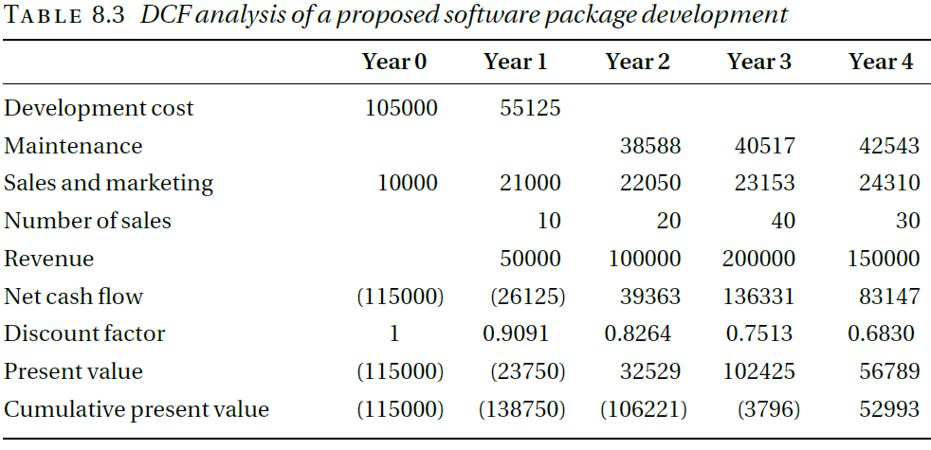

**PITFALLS OF DCF**

we must take into account that:

* most software projects take more effort than expected;
* most software doesn’t work very well when it’s first released;
* we may not manage to sell as many copies as we expected;
* there is a considerable risk that a competitor will launch a similar product before ours is ready.

**Lecture = 12**

**Structure and Management of Organizations**

* How Organizations are structured?
* How can you suggest alternative possible structures and identify their advantages and disadvantages.

**Introduction**

Definition: An organization is a group of people working together in a formal way.

Explanation: The work that has to be done is shared between these people and there are rules about who does what.

How the work is shared and how tasks and people are grouped together – the structure of the organization – will vary very much from organization to organization. It is surprising, however, that organizational structures have much more in common than might be expected.

**ORGANIZATIONAL MODELS**

* The bureaucratic model
* The organic model
* Matrix management

**The bureaucratic model**

Organizational theory is the study of how organizations are structured and how they work.(19th century)

The founders of the theory were sociologists like Max Weber and Mary Parker Follett, and practical business people like Henri Fayol and Lyndall Urwick.

In a modified form, this model still describes the organizational structures to be found in most large, and many smaller, organizations.

**The bureaucratic model characteristics**

The ideal bureaucratic organization was thought to have the following characteristics:

1. All tasks are split up into specialized jobs, in which jobholders become expert; management can thereby hold the jobholders responsible for the effective performance of their duties.
2. The performance of each task is governed by precise rules. This means that there should be no variation in the way tasks are carried out and therefore no problems with the co-ordination of different tasks.
3. Each individual (and hence each unit) in the organization is accountable to one and only one manager.
4. In order to ensure that personalities and personal relationships do not interfere with the organization’s performance, employees are required to relate both to other employees and to clients in an impersonal and formal manner.
5. Recruitment is based on qualifications and employees are protected against arbitrary dismissal. Promotion is based on seniority and achievement. Life-time employment is envisaged.

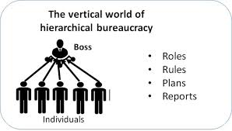

**The organic model**

The best known alternative model is the *organic* model

Rensis Lickert expresses the basic assumption of the model in the following (rather verbose) terms:

“An organization will be effective to the extent that its structure is such as to ensure a maximum probability that in all interactions and in relationships within the organization, each member, in the light of his background, values, desires, and expectations, will view the experience as supportive and one which builds a sense of personal worth and importance.”

**Key features of organic model**

* This view underlies the organizational structure of most small professional companies – software houses, advertising agencies, even solicitors’ and GPs’ practices
* it is also common in academic institutions, both schools and universities. The view is not necessarily consciously articulated – nor is this view and the adoption of the structures it suggests sufficient to achieve effectiveness!
* Proponents of the bureaucratic model claim that it is universally applicable.
* Proponents of the organic model make similar claims.
* It says little for common sense that those who hold the obvious view that each has its appropriate place should be christened adherents of the contingency school of organizational design.

**Matrix management**

* It is an essential feature of the bureaucratic model that every individual and every unit in the organization is responsible to only one manager.
* This is not realistic in the context of project-based, high-technology companies.
* It accepts that individuals may be responsible to more than one manager and requires rules that will enable possible conflicts to be resolved.
* Some organizations and some management consultants have tried to formulate the matrix management model much more formally. The results are not encouraging.

A specialist in high-speed communications working for a systems integrator may well find themselves working on two or three projects simultaneously, as well as having a more general responsibility for maintaining the company’s expertise in the area.

In the past 30 years or so the idea of matrix management has become fashionable as a way of addressing such situations.

**STRUCTURING PRINCIPLES**

* Structure by function
* Structure by geography
* Product line structure
* Structure by market sector
* Structure by technology
* Operational structure

**Structure by function**

There are the activities that are the primary purpose of the organization. These activities are known as *operations*.

All organizations have to pay their bills and pay their employees. They need to ensure that the buildings they use are cleaned regularly. If they charge for their services, they may need to send out bills and ensure that these are paid. They will probably need to hire new employees from time to time. These activities are generally known as *administration*.

Many organizations will need to publicize their services or their products and try to persuade people to use them or buy them. In the business world these activities are usually known as *sales and marketing*.

Finally, many organizations need to be continually developing new products or services, or developing new ways to deliver them. These activities are known as research and development.



**Functional Organizational Structures: “Typical” Functional Organizational Structure**

General Manager

Engineering

Manufacturing

Marketing

Finance and

Accounting

Personnel

Research and

Development

**Process-Oriented Functional Structure**

General Manager

Foundry

And

Castings

Milling

And

Grinding

Screw

Machining

Finishing

And Heat

Treating

Inspection

Loading

And

Shipping

Customer

Service

Billing

And

Accounting

**Functional Organizational Structures: Strategic Advantages/Disadvantages:**

***Strategic Advantages***

* Permits centralized control of strategic results
* Promotes in-depth functional expertise
* Enhances operating efficiency where tasks are routine and repetitive

***Strategic Disadvantages***

* Poses problems of functional coordination
* Can lead to interfunctional rivalry, conflict, and empire-building
* May promote overspecialization/ narrow viewpoints

**Structure by geography**

* In many cases it makes sense to group activities together on a geographical basis. Multinational companies, that is, companies that operate in a number of different countries, are usually forced to have some geographical elements in their structure.
* The subsidiaries are subject to the laws of the countries in which they are registered, in particular, the laws regarding employment, accounting and taxation.
* Within a single country, geographical factors have become less important as a result of the development of modern communications and, as a result, geographical structures have been replaced by structures based on other factors.

**Geographic Organizational Structure**

Chief Executive

**Corporate Staff**

Finance and Accounting

Personnel

Marketing Services

Legal

Planning

Research and Development

**General**

**Manager**

Western

District

**General**

**Manager**

Southern

District

**General**

**Manager**

Central

District

**District Staff**

Personnel

Accounting and Control

**General**

**Manager**

Eastern

District

**General**

**Manager**

Northern

District

Engineering

Production

Marketing

**Geographic Organizational Structures: Strategic Advantages/Disadvantages**

***Strategic Advantages***

*Strategic Disadvantages*

* Greater difficulty in maintaining consistent company image across areas
* Can result in duplication of staff services at headquarters and district levels, making a relative-cost disadvantage

***Strategic Disadvantages***

* Greater difficulty in maintaining consistent company image across areas
* Can result in duplication of staff services at headquarters and district levels, making a relative-cost disadvantage

**Product line structure**

A product line structure is a structure that is based around the different types of product that an organization produces.

For example, where a motor vehicle manufacturer organizes around types of vehicle.

* Companies that produce and market a substantial piece of software for corporate customers – a multi-user accounting package
* For example – often organize themselves into three main operational divisions: development and maintenance of the software, consultancy, and training. This should be regarded as a product line structure since the three types of activity, providing software, giving advice to companies in how to use it, and providing training for customer staff, can be considered to be different services that the company provides and they are typically provided by different teams of people.

**Structure by market sector**

* Structure by market sector means structure based on the different market sectors to which its customers or prospective customers belong.
* From the sales and marketing point of view it has the great advantage that each division can fairly readily identify its potential customers, and its staff, both sales and technical, are likely to be familiar with customers’ problems and to speak a language that the customer understands.
* Example :

Different branches of BATA

Automobiles

**Disadvantages**

There are two dangers with this approach.

* There is the risk one division may be unaware of technological expertise that exists in another division. This may lead to inefficient use of resources through unnecessarily hiring additional specialists or employing consultants, or, worse, to failing to learn from mistakes that have been made by other parts of the company.
* The second danger with a structure based on market sector is that, by continuing to concentrate on its traditional areas even when these markets are becoming saturated, the company will miss new opportunities and will stagnate.

**Structure by technology**

* A technology-based structure was once a favorite model for software companies.
* A company might have divisions specializing in artificial intelligence, communications, web-based systems, databases, and real-time systems.
* There are several problems with type of structure: it usually requires several different technologies to meet a customer’s needs;
* there are many applications that cannot be said to require specific technologies;
* there are many competent software engineers whose expertise runs across a number of technologies;
* it is difficult, if not impossible, for sales and marketing staff to predict which potential clients will need which technology. It is particularly serious and companies that are primarily structured by technology have serious problems finding their clients.
* They are not sufficiently ‘customer-focused’ – they concentrate on selling the technologies that they have rather than finding out what the customer needs.

**Operational structure**

* The actual operations of a company may be organized on a *project* basis or on a *production* basis, although the line separating the two may be vague.
* Project-based activity is not restricted to operations. Most research and development is organized on a project basis and such administrative activities as introducing a new accounting system or transferring a company’s head office are also to be regarded as projects, in that they last for a fixed length of time, after which they should be complete.
* Projects last a comparatively long time but the team carrying out the work only stays together for the length of the project. Production activities are comparatively short, but the team carrying them out stays in existence indefinitely.

**DEPTH OF STRUCTURE**

The depth of an organizational structure is the number of layers in the

structure – or, more precisely, the maximum number of layers, since not all

parts of the structure will have the same number of layers. Organizational

structures are often described as flat or, in contrast, deep or tall, according

to whether the depth is small or large. For a given number of people, the

depth of the structure will obviously depend on the number of people reporting

directly to each manager; this is sometimes known as the manager’s *span*

*of control*.

**Fifteen people organized into a four-level structure**



**CENTRALIZATION**

* Organizations may be centralized or decentralized. In a centralized company, as much power as possible is kept at the top of the company, with delegation only when essential. In a decentralized company, as much power and control as possible is delegated to the lowest level.

**SETTING UP A STRUCTURE IN PRACTICE**

In most cases, an organization of any size will have a structure that includes elements of several of the different types of structure.

A combination of different structures would help when adopted.

**An organizational structure for a bespoke software house**



**Lecture = 13**

**Human Resources Issues**

* What are the complexity of the law in this area;
* What are the constraints under which management and human resources staff act;
* why and to what extent managers need to be aware of general human resources issues.

**Human resources**

* What is a resource?
* What is human resource?
* Why do we need Human Resources in organization?
  + Helps organizations navigate the more than 180 labor laws governing how organizations hire and manage people

**THE LEGAL CONTEXT**

* In 20th centuary, industrial relations in the UK were based on collective bargaining and were conceived very much in terms of relations between trade unions and employers. In particular, the rights of trade unions received much more prominence than the rights of individual employees.
* Strikes were a common weapon for bargaining.

**Individual employee/ unions**

The greater attention paid to the rights of individual employees and the need to comply with anti-discrimination legislation have very considerably increased the workload of human resources departments in the UK..

**HR Activities**

The following list is a summary of the tasks that are expected to undertake within the overall aim of ensuring that the organization has the workforce that it needs:

* ensuring that recruitment, selection and promotion procedures comply
* with anti-discrimination legislation;
* staff training and development;
* setting up and monitoring remuneration policy;
* setting up and monitoring appraisal procedures;
* administering dismissal and redundancy procedures;
* dealing with contracts of employment;
* workforce planning;
* administering grievance procedures;
* being aware of new legislation affecting employment rights and advising management of what the organization must do to comply with it;
* dealing with health and safety;
* administering consultative committees

**RECRUITMENT AND SELECTION**

Human resources managers often make a distinction between the two terms recruitment and selection, using recruitment is to mean soliciting applications and selection is to mean selecting the applicants to whom offers will be made.

Selection is kept in the hands of the employer, although a member of the recruitment agency staff may sometimes be invited to advise.

**Selection tools**

A wide range of selection techniques is available and is used in making professional appointments:

* A series of one-to-one interviews with senior management and senior technical staff.
* Interview by a panel: A number of interviewers are involved. This technique is widely used, particularly in the public sector. It tends to favour applicants who are smooth talkers. It is unreliable.
* Assessment of references: Great importance is usually attached to references for academic posts and some other posts in public bodies.
* Psychometric tests: These are of three types. *Ability tests* measure an individual’s ability in a general area, such as verbal or numerical skills. *Aptitude tests* measure a person’s potential to learn the skills needed for a job. *Personality tests* attempt to assess the characteristics of a person that significantly affect how they behave in their relationships with other people.
* Situational assessment: Real time situations are given to shortlisted candidates. Its most expensive and used in military officers selection.
* Task assessment: Candidates are asked to carry out some of the tasks that they will be required to do in the job. People usually are able to do small tasks but unable to do large task so this is unfavourable.

**STAFF TRAINING AND DEVELOPMENT**

Training and development encompasses three main activities: training, education, and development.It is a function concerned with organizational activity aimed at bettering the performance of individuals and groups in organization. It has been known by several names, including "Human Resource Development", "Human Capital Development" and "Learning and Development".

Staff training and development are of particular importance in high technology companies, where failure in this respect can threaten the company’s performance

It is unfortunate that, when money is tight, it is often the first thing to be cut.

**REMUNERATION POLICIES AND JOB EVALUATION**

* **Remuneration** is the compensation that one receives in exchange for the work or services performed. Typically, this consists of monetary rewards, also referred to as wage or salary. A number of complementary benefits, however, are increasingly popular remuneration mechanisms.
* For grading and scaling polices are developed and job evaluation are held.

**APPRAISAL SCHEMES**

* Appraisal (Performance appraisal)is a method by which the job performance of an employee is documented and evaluated
* Need of Appraisal?
* Appraisal schemes usually involve an appraiser and an appraisee meeting

regularly (every six months, every year, even every two years) to discuss the

employee’s performance and career development under a number of headings.

The result is a report signed by both parties; if they cannot agree on certain

points this will be recorded in the report.

**REDUNDANCY and DISMISSAL**

* Unfair dismissal
* Reasons justifying dismissal:
  + - lack of capability;
    - misconduct;
    - breach of the law
    - Redundancy
    - Constructive dismissal

**Unfair dismissal vs wrongful dismissal**

* Dismissal of an employ without valid reasons is unfair
* A fair dismissal of an employee but violating a contract is wrongful dismissal

**Take overs and out sourcing**

* Employees employed by the previous employer when the undertaking changes hands *automatically* become employees of the new employer on the same terms and conditions. It is as if their contracts of employment had originally been made with the new employer. Thus employees’ continuity of employment is preserved, as are their terms and conditions of employment under their contracts of employment (except for certain occupational pension rights).
* Representatives of employees affected have a right to be informed about the transfer. They must also be consulted about any measures which the old or new employer envisages taking concerning affected employees.

**Public interest disclosures**

* Whistle blowers
* The Public Interest Disclosure Act 1998 (PIDA) applies to people at work who raise concerns about criminal behaviour, certain types of civil offences, miscarriages of justice, activities that endanger health and safety or the environment, and attempts to cover up such malpractice.

**CONTRACTS OF EMPLOYMENT**

* What is a contract?

the written agreement between an employee and their employer can be enforced in a court of law.

* A good contract of employment should be written in terms that are easily understood and should avoid legal conflicts.

**HUMAN RESOURCE PLANNING**

* If the human resources department is to ensure that the organization always has available the staff it needs, it must be able to forecast the needs some time ahead.
* In a software house, there are three inputs to the human resource planning process:
  + Human resource plans from existing projects,
  + Sales forecasts
  + Forecasts of the likely staff losses in the coming months

**JOB DESIGN**

* Job rotation: Job rotation, that is, rotating staff through a series of jobs, is the most obvious way of preventing employees from becoming bored with a very narrow and specialized task.
* Job enlargement: **Job enlargement** means increasing the scope of a job through extending the range of its job duties and responsibilities generally within the same level and periphery. Job enlargement involves combining various activities at the same level in the organization and adding them to the existing job
* Job enrichment: **Job enrichment** can be described as a medium through which management can motivate self-driven employees by assigning them additional responsibility normally reserved for higher level employees. By doing this, employees *feel* like their work has meaning and is important to the company
* **Question :**
* **A**
* **1. What is a resource?**
* **2.What is human resource?**
* **3.Why do we need Human Resources in organizations?**
* **Give one example each to support your answer.**
* **B**
* **1. How many ways are JOB DESIGNS perfomed ? Give an example for each.**

**Lecture = 14**

**Anti-Discrimination Legislation**

* What is Discrimination?
* *what anti-discrimination laws are trying to do*
* *why your employer has codes of practice that you are expected to follow in order to avoid breaching the legislation*
* *Why, if you become involved with discrimination issues at any deeper level, you should seek advice from a professional in the field, sooner rather than later.*

**WHAT IS DISCRIMINATION?**

* Discrimination means treating one person or one group of people less favorably than another on the grounds of personal characteristics.
* Discrimination can be *direct* or *indirect*.

**Discrimination Grounds**

In Europe, the USA and many other countries prohibits discrimination on grounds such as:

* sex, Gender;
* race, colour, ethnic origin or nationality;
* disability;
* sexual orientation;
* religion;
* age.

**Direct discrimination**

* Direct discrimination occurs when one person is treated less favourably than another specifically because of their sex or race, and so on.

**Examples**

* + A woman does exactly the same job as a man but is paid less than he is.
  + A doctor refuses to treat a Chinese patient on the grounds that he has no room for any more patients but then accepts an English patient.
  + A company advertises for a secretary and automatically rejects all the male applicants.
  + A company advertises for ‘a mature woman to act as the Chief
  + Executive’s personal assistant’ or ‘a strong young man to work as a trainee zoo-keeper’.

**Indirect discrimination**

Indirect discrimination occurs when an employer imposes conditions that apply to all employees or all applicants but have a disproportionate effect on one group.

**Examples**

* + Advertising a job with the requirement that applicants must be at least 180 cm tall. In the UK, there are many men over 180 cm tall but very few women. The result is that few women can apply for the job.
  + When allocating public housing, a local authority has a policy of giving priority to the children of existing tenants.
  + An employer insisting that all employees work on Saturdays. This might be held to be indirect discrimination against those who practice Judaism, since Saturday is their Sabbath. This would be discrimination on grounds of religion but, since the practitioners of Judaism are overwhelmingly of the Jewish race, it might also be regarded as racial discrimination.

It can be justified if the employer demonstrates that there is a genuine occupational requirement that the offending condition be satisfied.

**DISCRIMINATION ON GROUNDS OF Gender**

* Formally women got low salaries and men got extra allowances and more if they are married
* Married women were either to loose their job or transferred to temporary status
* Women after having kids were not allowed to rejoin
* it was very difficult for women to gain entry to academic and professional courses in fields such as medicine or the law that would have qualified them for senior positions.

**Act of Parliment**

In UK this situation was dramatically changed by two Acts of Parliament:

* the Equal Pay Act of 1970 and
* the Sex Discrimination Act of 1975.

The most important features of the law as it stands can be summarized as follows:

* Regarding Employment
* Regarding Education
* Regarding Provision of services

**Act of Parliament Regarding Employment**

* It is unlawful for an employer to discriminate against a person on grounds of their sex or marital status in terms of the arrangements made for recruitment and selection and the terms on which employment is offered.
* It is unlawful for an employer to discriminate against an employee on grounds of their sex or marital status in regard to opportunities for promotion, transfer or training or to any other benefits.
* It is unlawful for an employer to discriminate against an employee on grounds of their sex or marital status in regard to dismissal or redundancy.
* It is unlawful for an employer to victimize an employee for bringing a complaint of sex discrimination or for giving evidence in support of another employee’s complaint.
* It is unlawful for any of the following to discriminate against a person on grounds of sex or marital status: a trade union, a professional body, a registration authority, an employment agency or a provider of vocational training.

**Act of Parliament Regarding Education**

* It is unlawful for a provider of education (public or private, school, college or university) to discriminate against a person on the basis of their sex, in offering admission to the establishment or to specific courses, and in providing access to the other benefits and facilities it offers.
* The main exceptions to this are that allowance is made for single-sex establishments and that provision for physical education may be different for the two sexes.

**Act of Parliament Regarding Provision of services**

* It is unlawful to discriminate on grounds of sex in the provision of goods, facilities or services. The Act gives a number of examples including accommodation in a hotel, facilities for entertainment, recreation or refreshment, banking and insurance services, and so on.
* It is unlawful to discriminate on grounds of sex in selling or letting property.

The main exception to these provisions are for charities that have been founded with the purpose of helping a specific group of people who are all of the same sex, for example, single mothers**.**

**Remedies**

Bring the matter to an employment tribunal. If the tribunal finds in favour of the complainant, it can award damages and make recommendations to the respondent. If the respondent fails to act on the recommendations, the amount of the damages may be increased.

**DISCRIMINATION ON RACIAL GROUNDS**

* The present law is based on the Race Relations Act 1976 and subsequent amendments to it.
* It makes it unlawful to discriminate on grounds of race, colour, ethnic origin or nationality.
* It introduced the idea of indirect discrimination based on race. And it established the Commission for Racial Equality by the merger of the Race Relations Board and the Community Relations Commission.

**DISCRIMINATION ON GROUNDS OF DISABILITY**

* From the 1970s onwards, government had been encouraging the recruitment of disabled employees into the Civil Service and encouraging employers to take on disabled workers by withholding government contracts from companies that could not demonstrate a commitment to offering opportunities to the disabled

**Disability Discrimination Act 1995**

The Act makes it unlawful to treat a disabled employee or applicant less

favourably because of their disability without justification. The justification

must be serious and substantial. Thus it would be justified to reject a blind

applicant for a job as a bus driver or a paraplegic for a job as a lifeguard.

**Survey**

The Disability Rights Commission commissioned a study of web accessibility for the disabled, which resulted in a report entitled The Web: Access and Inclusion for Disabled People. The study included a survey of 1,000 home pages and found that 81 per cent, including many government sites, failed to comply with even the lowest level of the W3C guidelines. Among the commonest reasons why disabled users experienced difficulty were:

* page layout was unclear and confusing;
* the navigation mechanisms were confusing and disorienting;
* there was poor contrast between the text and the background and colours were used inappropriately;
* graphics and text were too small;
* links and images were poorly labelled;
* the web pages were incompatible with the software designed to assist disabled users (screen readers, magnification software).

**DISCRIMINATION ON GROUNDS OF RELIGION OR BELIEF, OR SEXUAL ORIENTATION**

As regards discrimination on grounds of sexual orientation and religious

belief, the EU directive is implemented in the UK by the Employment

Equality (Sexual Orientation) Regulations 2003 and the Employment

Equality (Religion or Belief) Regulations 2003, both of which came into effect

in December 2003. These regulations follow the pattern established by the

Sexual Discrimination Act 1975 and the Race Relations Act 1976.

**Employment Equality (Sexual Orientation and Religion or Belief) Regulations 2003,**

* They are limited to discrimination in employment, education, and related matters, and do not refer to discrimination in the provision of services or accommodation, for example.
* They explicitly make harassment unlawful, defining it as ‘unwanted conduct which has the purpose or effect of violating a person’s dignity or creating an intimidating, hostile, degrading, humiliating or offensive environment. Although the courts and industrial tribunals had accepted that racial or sexual harassment constituted discrimination, this was not explicitly covered by previous anti-discrimination legislation.
* They do not make any body, such as the Commission for Racial Equality, responsible for promoting the implementation of the legislation nor do they create any new body for this purpose. However, in October 2003, the government announced its plans for a single equality body for the UK to take over the responsibilities of the Equal Opportunities Commission, the Commission for Racial Equality, and the Disability Rights Commission.

**DISCRIMINATION ON GROUNDS OF AGE**

The Equal Treatment Directive is careful to be quite explicit in allowing for discrimination on the grounds of age in a number of important cases. It allows, for example:

* special treatment of different age groups in order to protect them (e.g. not allowing children under a certain age to be employed);
* different premiums for life insurance policies, depending on the age of the person at the time the policy is taken out, and different pension rates depending on the age of retirement (but these must not amount to sex discrimination);
* fixing a maximum age for recruitment based on the need for a reasonable period of employment after training and before retirement;
* fixing a minimum age, a minimum amount of professional experience or a minimum number of years with the company before a person will be regarded as eligible for a given post or eligible for certain employment benefits (e.g. additional annual leave).

**AVOIDING DISCRIMINATION**

Effective compliance with anti-discrimination legislation in the workplace requires three things:

* a suitable written policy, well publicized, and freely and easily available;
* a training program for new and existing staff, to ensure that they are all aware of the policy and its importance;
* effective procedures for implementing the policy.

**Lecture = 15**

**Software Contracts and Liability**

What is a contract?

A contract is simply an agreement between two or more persons (the *parties*

to the contract) that can be enforced in a court of law. The parties involved

may be legal persons or natural persons.

**Essentials for a contract**

The most important and essential concerns of a contract are that:

* all the parties must intend to make a contract;
* all the parties must be competent to make a contract, that is, they must be old enough and of sufficiently sound mind to understand what they are doing;
* there must be a ‘consideration’, that is, each party must be receiving something and providing something**.**

**FIXED PRICE CONTRACTS FOR BESPOKE SYSTEMS**

* The first type of contract we shall consider is the type that is used when an organization is buying a system configured specifically to meet its needs. Such systems are known as *tailor-made* or *bespoke* systems.
* A bespoke system may consist of a single PC equipped with a word processor, a spreadsheet, and a set of macros adapted to the customer’s needs or it may consist of several thousand PCs spread across 50 offices in different parts of the world, connected by a wide-area network, with large database servers and a million lines of specially written software**.**

**Bespoke system**

The contract for the supply of a bespoke system consists of three parts:

* A short *agreement*, which is signed by the parties to the contract: This states who the parties are and, very importantly, says that anything that may have been said or written before does not form part of the contract.
* The *standard terms and conditions*, which are normally those under which the supplier does business; and
* A set of *schedules* or *annexes*, which specify the particular requirements of this contract, including what is to be supplied, when it is to be supplied, what payments are to be made and when, and so on.

**Issues in contract**

* What is to be produced
* What is to be delivered
* Ownership of rights
* Confidentiality
* Payment terms
* Penalty clauses
* Obligations of the client
* Standards and methods of working

**What is to be produced**

* It is clearly necessary that the contract states what is to be produced.
* requirements specification

It is important that the reference to the requirements specification identifies that document uniquely; normally this will mean quoting a date and issue number.

Problem: Any changes needed during the contract life

**What is to be delivered**

The following is a non-exhaustive list of possibilities:

* source code;
* command files for building the executable code from the source and for

installing it;

* documentation of the design and of the code;
* reference manuals, training manuals and operations manuals;
* software tools to help maintain the code;
* user training;
* training for the client’s maintenance staff;
* test data and test results.

**Ownership of rights**

It is important that the contract should also state just what legal rights are being passed by the software house to the client under the contract.

Ownership in physical items such as books, documents or disks will usually pass from the software house to the client, but other intangible rights, known as intellectual property rights, present more problems.

**Confidentiality**

* when a major bespoke software system is being developed, the two parties will acquire confidential information about each other.
* Non of the parties would like the other to disclose its secrets.
* It is usual in these circumstances for each party to promise to maintain the confidentiality of the other’s secrets, and for express terms to that effect to be included in the contract.

**Payment terms**

a pattern of payments such as the following must be included:

* an initial payment of, say, 15 per cent of the contract value becomes due
* on signature of the contract;
* further stage payments become due at various points during the development,
* bringing the total up to, say, 65 per cent;
* a further 25 per cent becomes due on acceptance of the software;
* the final 10 per cent becomes due at the end of the warranty period.

**Calculating payments for delays and changes**

* Both sides of the parties may create little or high loss regarding unable of meeting the timeline. Thus extra work has to be indulged producing extra payments
* The contract must specify the process by which these extra payments are to be calculated.

**Penalty clauses**

The previous subsection dealt with compensation for delays caused by the client; delays caused by the supplier are handled differently.

Delays in delivering working software are notoriously common; it might therefore be expected that contracts for the supply of software would normally include such a penalty clause. There are three reasons for this:

* Suppliers are very reluctant to accept penalty clauses and anything stronger than the example quoted above is likely to lead to reputable suppliers refusing to bid.
* If the contract is to include penalty clauses, the bid price is likely to be increased by at least half the maximum value of the penalty.
* If the software is seriously late and penalties approach their maximum, there is little incentive for the supplier to complete the work since they will already have received in stage payments as much as they are going to get.

**Standards and methods of working**

The supplier is likely to have company standards, methods of working, quality assurance procedures, and so on, and will normally prefer to use these. More sophisticated clients will have their own procedures and may require that these be adhered to. In some cases, the supplier may be required to allow the client to apply quality control procedures to the project.

The contract must specify which is to apply.

**Project meeting**

Regular progress meetings are essential to the successful completion of a

fixed price contract and it is advisable that standard terms and conditions

require them to be held. The minutes of progress meetings, duly approved

and signed, should have contractual significance in that they constitute evidence

that milestones have been reached (so that stage payments become

due) and that delay payments have been agreed.

**Project managers**

Each party needs to know who, of the other party’s staff, has day-to-day

responsibility for the work and what the limits of that person’s authority are.

The standard terms and conditions should therefore require each party to

nominate, in writing, a project manager. The project managers must have at

least the authority necessary to fulfil the obligations that the contract places

on them. It is particularly important that the limits of their financial authority

are explicitly stated, that is, the extent to which they can authorize changes to

the cost of the contract.

**Acceptance procedures**

Acceptance procedures are a critical part of any fixed price contract for they

provide the criteria by which successful completion of the contract is judged.

The essence of the acceptance procedure is that the client should provide a

fixed set of acceptance tests and expected results and that successful performance of these tests shall constitute acceptance of the system. The tests

must be provided at or before the start of the acceptance procedure; within

reason, there may be as many tests as the client wishes, but extra tests cannot

be added once the test set has been handed over. The purpose of this restriction is to ensure that the acceptance procedure can be completed in reasonable time.

Other points to be addressed under this heading include who shall be

present when the tests are carried out and what happens if the tests are not

completed successfully.

**Warranty and maintenance**

Once the product has been accepted, it is common practice to offer a warranty

period of, typically, 90 days. Any errors found in the software and reported

within this period will be corrected free of charge. This clause is, of course, subject to negotiation; reducing or eliminating the warranty period will reduce the overall cost of the contract and prolonging the period will increase it.

Once the warranty period is over, the supplier may offer, or the client

demand, that maintenance will continue to be available on request. Since

such maintenance is likely to involve enhancement of the software rather

than simply correction of faults, the resources required are unpredictable –

the client almost certainly does not know what enhancements will be

required in two years’ time. For this reason, a fixed price for the maintenance

will not be appropriate. Maintenance will therefore usually be charged on a

time and materials basis; the client may possibly be required to commit to

taking a fixed number of days of effort each year in order to compensate the

supplier for the need to retain knowledge of the system.

**Inflation**

In lengthy projects or projects where there is a commitment to long-term maintenance, the supplier will wish to ensure protection against the effects of unpredictable inflation. To handle this problem, it is customary to include a clause which allows charges to be increased in accordance with the rise in costs.

The clause should state how often (once a year, twice a year) charges can be increased and how the effect on the overall price is to be calculated.

**Indemnity**

It could happen that, as a result of the client’s instructions, the supplier is led

unwittingly to infringe the intellectual property rights of a third party or that,

through carelessness or dishonesty, the supplier provides a system which

infringes such rights – perhaps through using proprietary software as a component

of the system delivered. For this reason, it is advisable to include a

clause under which each party indemnifies the other (that is, guarantees to

cover any costs the other party becomes subject to) for liability arising from

its own faults in this respect**.**

**Termination of contract**

There are many reasons why it may become necessary to terminate a

contract before it has been completed. It is not uncommon, for example,

for the client to be taken over by another company that already has a

system of the type being developed, or for a change in policy on the part of the

client to mean that the system is no longer relevant to its needs. It is essential,

therefore, that the contract make provision for terminating the work in an

amicable manner. This usually means that the supplier is to be paid for all the

work carried out up to the point where the contract is terminated, together

with some compensation for the time needed to redeploy staff on other

revenue earning work. The question of ownership of the work so far carried

out must also be addressed.

**Arbitration**

An arbitration clause will usually state that, if arbitration is required, it will take place in accordance with the Arbitration Act 1996. This Act of Parliament lays down a set of rules for arbitration that cover many eventualities, and reference to it avoids the need to spell these out in detail; most of the provisions of the Act are optional, in the sense that they come into effect only if the contract contains no alternative provision.

**Applicable law**

Where the supplier and the client have their registered offices in different legal jurisdictions or performance of the contract involves more than one jurisdiction, it is necessary to state under which laws the contract is to be interpreted.

**CONSULTANCY AND CONTRACT HIRE**

**Consultancy**

* End product of a consultancy project is usually a report or other document.
* Under normal circumstances a fee for IT consulting is measured on a per day, per consultant basis.
* Fixed fee IT consulting contract applies to projects which are well defined.
* Open ended consultancy models generally favour the consulting firm, as the consultancy firm is rewarded on a per day basis, there is no incentive to complete assignments within a fixed time. The result often being risk of project and cost overrun.
* Contract is very simple.

**Contract hire**

* Supplier’s responsibility is limited to providing suitably competent people and replacing them if they become unavailable.
* The staff work under the direction of the client.
* Payment is on the basis of a fixed rate for each day worked.
* Ownership of intellectual property rights generated in the course of the work may be needed to be addressed.

There are four important aspects of a consultancy contract:

**Confidentiality:** Consultants are often in a position to learn a lot about

the companies for which they carry out assignments and may well be in

a position to misuse this information for their own profit.

**Terms of reference:** It is important that the contract refers explicitly to

the terms of reference of the consultancy team and, in practice, these

are perhaps the commonest source of disagreements in consultancy

projects. As a result of their initial investigations, the consultants may

discover that they need to consider matters that were outside their original

terms of reference but the client may be unwilling to let this happen,

for any one of a number of possible reasons;

**Liability:** Most consultants will wish to limit their liability for any loss

that the customer suffers as a result of following their advice. Customers may not be happy to accept this and, in some cases, may insist on verifying

that the consultant has adequate professional liability insurance.

**Who has control over the final version of the report:** It is common practice

for the contract to require that a draft version of the final report be

presented to the client. The client is given a fixed period to review the

report and, possibly, ask for changes. The revised version that is then

submitted by the consultant should be the final version.

**Time and Materials**

A time and materials contract (often referred to as a ‘cost plus’ contract) is

somewhere between a contract hire agreement and a fixed price contract.

The supplier agrees to undertake the development of the software in much

the same way as in a fixed price contract, but payment is made on the basis of

the costs incurred, with labour charged in the same way as for contract hire.

The supplier is not committed to completing the work for a fixed price,

although a maximum payment may be fixed beyond which the project may

be reviewed**.**

**OUTSOURCING**

Outsourcing, sometimes known as facilities management, is the commercial arrangement under which a company or organization (the customer) hands over the planning, management and operation of certain functions to another organization (the supplier).

IT outsourcing contracts are inherently complex and depend very much

on individual circumstances. It is not appropriate to go into detail here about

such contracts but the following is a list of just some of the points that need to

be addressed:

**Key points of outsourcing**

* how is performance to be monitored and managed;
* what happens if performance is unsatisfactory;
* which assets are being transferred;
* staff transfers;
* audit rights;
* contingency planning and disaster recovery;
* intellectual property rights in software developed during the contract;
* duration of the agreement and termination provisions.

**HEALTH AND SAFETY**

The ones that are of particular concern to software engineers are:

* provision and maintenance of safe plant;
* provision and maintenance of safe systems of work;
* provision of such information, instruction, training, and supervision as necessary;
* ensuring the workplace is maintained in a safe condition;
* provision and maintenance of a safe working environment and adequate welfare arrangements.

The Act also requires employers to ensure that their activities do not expose the general public to risks to their health and safety. Manufacturers of equipment to be used at work also have a responsibility to ensure that it is safe.

Failure to comply with the Health and Safety at Work Act is a criminal offence and, in serious cases, can lead to criminal proceedings being taken against individuals.